Challenge Number: 996
Played on date: November 9, 2019 Time: 19:00
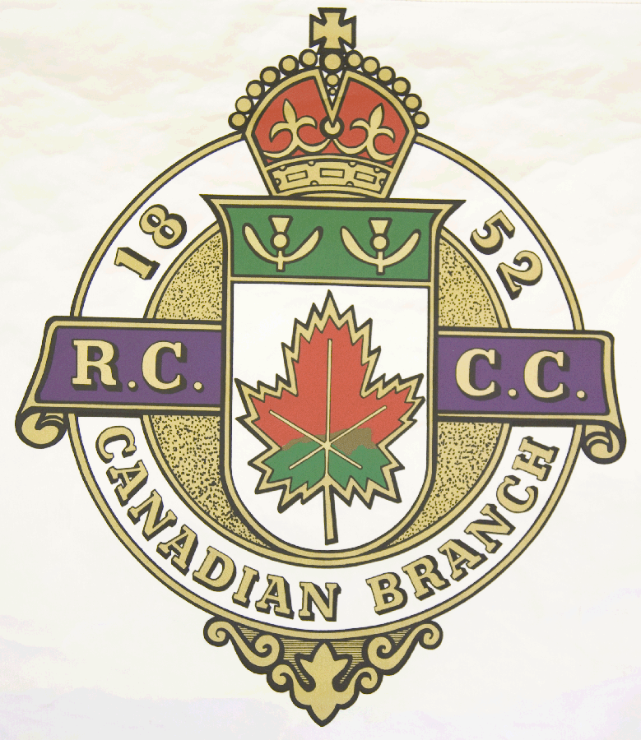
Hosting Club: Pembroke Curling Club

Host Club Address: 428 Herbert Street

Host Club City: Pembroke, Ontario

Host Club Telephone: 613 - 732 - 4113

Host Contact Person: David Trautrim

Contact phone or email: dtrautrim@gmail.com

Hosting Club: Pembroke Challenging Club: Deep River

Skip: Shawn Patterson Skip: Malcolm James

Third: Nevin Gaudon Third: Kevin McCrimmon

Second: Richard Elliot Second: Toban Verdun

Lead: Chris Cowan Lead: Brock Sanderson

Skip: Marcel Jonckheere Skip: Leo Buckley

Third: Caleb Hall Third: Chris Knight

Second: Mathieu Fournier Second: Mike Moore

Lead: Mike Alexander Lead: Brad Payne .

 | Skip | 1 | 2 | 3 | 4 | 5 | 6 | 7 | 8 | 9 | 10 | Score
Sheet  2 | Patterson | 2 | 1 |  |  | 1 |  |  | 1 | 1 |  | 6
Sheet  2 | James |  |  | 1 | 2 |  | 2 | 1 |  |  | 1 | 7
Sheet  3 | Jonckheere | 2 |  |  |  | 3 |  |  | 2 |  |  | 7
Sheet  3 | Buckley |  | 1 | 1 | 1 |  | 1 | 1 |  | 2 | 1 | 8

Hosting club Score: 13____ Challenging club score: __ 15____

Note: Description of the game should follow on separate page as well as photos of the teams.

